Organ donation
Donating your organs can be considered a final act of generosity however some people prefer their body to remain undisturbed after death.
It is important to me that my organs are donated after I die
I have registered as an organ donor
I do not want to donate my organs
It is up to my family if my organs are donated or not

Donation to science
If you wish to donate your body to science you need to arrange this before you die. It is not sufficient to leave instructions in a Will. Consequently, you will need to make arrangements with the institution of your choice (e.g. a university medical school) before your death.
I have donated my body to the following institution:
Arrangements have been made with the following person at
the institution and their contact details are:

Burial or cremation
I would prefer my body is cremated.
Ashes can be placed in a cemetery or a place special to you or
your family. You may wish for a tree to be planted over your
ashes or for your ashes to be scattered at a special time or
place.
I would like my ashes to be:
OR
I would prefer my body is buried.
It is possible in some circumstances to be buried on private
land but permission is usually required from the local council.
Approval and arrangements can be completed before you die.
My preferred place of burial is:

Cultural or religious preferences
Special practices that I would like observed after my death:
It is important that my body is cremated or buried within ____
hours of my death,
OR
It is important that my body is cremated or buried within ____
days of my death

Making your wishes known
Your wishes after your death
The person(s) from my faith tradition or community that I
would like to be notified of my death is:

Buddhist preferences
It is important that my body is not moved or touched for
______ hours / days after my death.
It is important that my body is not moved or touched until
After the final stage of the dying process is complete. This is
when my consciousness and body have finally separated and
there is no longer any warmth coming from my heart chakra.
Before my body is moved first pull the hair at the crown of my
head.
The prayers I wish recited on my behalf for 49 days after my
death are:

Funeral Service
I would like to be involved in planning my funeral, OR
I prefer to leave it to my family to arrange my funeral

Karuna also has experienced people you can talk with on:
07 3632 8300 or karuna@karuna.org.au

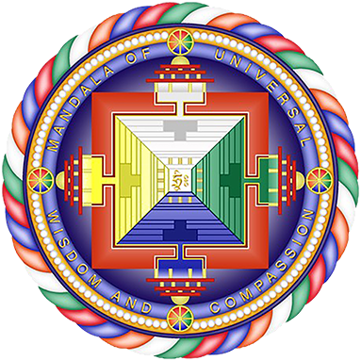

This is a Support and Learning resource. More resources available at www.karuna.org.au/resources. Karuna is affiliated with www.fpmt.org
This work is licensed under a Creative Commons
Attribution-NonCommercial-ShareAlike 4.0 International License SLID 1018 V3

